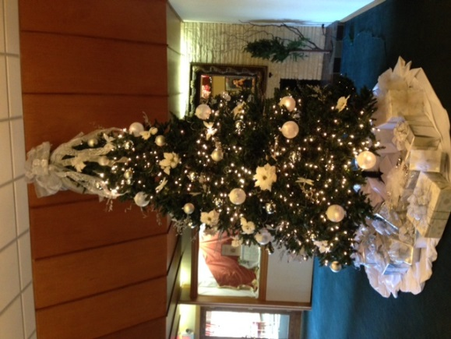

**$20 per person Includes:**

Fully decorated venue for the holiday season, your room fee*,

White table linens, white linen napkins, china place settings, cake cutting & service, coffee & soft drink service, select buffet, as well as professional banquet servers & bartenders.

**Black River Country Club**

**2017 Winter Event Package**

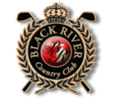

Cash Bar

(Host paid or Individual Option)

*Coffee Service provided after buffet

*Unlimited Soft drinks during event

**\*Add Beer & Wine Open Bar (4 hours) for $10**

**per person**

(Select 1 Salad)

Tossed Garden Salad ● Caesar Salad ● Potato Salad ●

Cole Slaw

(Select 1 Vegetable)

-Green Bean Almondine

-Sweet Corn Niblets

-California Blend

-Prince Edward Bean Blend

(Select 1 Starch)

-Mashed Potatoes with Gravy

-Herb Roasted Red Skins

-Garlic Mashed Potatoes

-Stuffing

For more info or

to book your date!

Contact Theresa

810-982-9595 ext. 3

Banquets@blackrivergolfclub.com

(Select 2 Main Entrées)

* Roasted Marinated Chicken
* Sliced Roast Sirloin with Mushroom Gravy
* Honey Baked Ham
* Traditional Lasagna with Meat
* Vegetarian Lasagna
* Sliced Roast Turkey
* Polish Sausage with Sauerkraut

**Add** Penne w/ Marinara Pasta +$1.00 p/p

**Add** Top Round Sirloin Carving Station +3.50 p/p

**Add** Additional Bar Time +$2 p/p

**Add** Cheesecake with topping or double chocolate cake for $2.50 p/p

**Add** Non-Alcoholic Punch Bowl- $1.25 p/p